Course Name: | Applied Cryptography | Semester: | V
Date of Performance: | 22/09/25 | DIV/ Batch No: | A1
Student Name: | Aaryan Sharma | Roll No: | 16010123012

Experiment No: 6
Title: Implementation of ECC as discrete logarithm problem

Aim and Objective of the Experiment:
- Understand the Concept of ECC
- Implentation

COs to be achieved:
CO3: Analyze and Implement Symmetric and ASymmetric Key Cryptography Algorithms

Books/ Journals/ Websites referred:
- Students own answer

Theory:
Define discrete logarithm problem for elliptic curves.:
Consider the equation Q = kP where Q, P ∈ EP(a, b) and k < p.
It is relatively easy to calculate Q given k and P, but it is hard to determine k given Q and P. This is called the discrete logarithm problem for elliptic curves.

Example:
Consider the group E₂₃(9,17).
This group is defined by the equation : y² mod 23 = (x³ + 9x + 17) mod 23.

What is the discrete logarithm k of Q = (4, 5) to the base P = (16, 5)?

The brute-force method is to compute multiples of P until Q is found. Thus,
P = (16,5);
2P = (20, 20);
3P = (14, 14);
4P = (19, 20);
5P = (13, 10);
6P = (7, 3);
7P = (8, 7);
8P = (12, 17);
9P = (4, 5) =Q

Because 9P = (4, 5) = Q, the discrete logarithm Q = (4, 5) to the base P = (16, 5) is k = 9.
In a real application, k would be so large as to make the Brute Force approach infeasible.

Problem statement
Part I
Implement point addition P+Q.
Implement point doubling 2P / Implement scalar multiplication kP using double-and-add method.

Part II - Given any points P(xp,yp) and Q(xq,yq), compute K, such that
Q=K*P.
Given Q = K × P, attempt to compute K using brute force (feasible only with very small curves).
Show that as p grows larger, brute force becomes computationally infeasible.

Code :
import time

a = 2
b = 2
p = 17
G = (5, 1)

def point_addition(P, Q, a, p):
if P is None: return Q
if Q is None: return P
x1, y1 = P
x2, y2 = Q
if x1 == x2 and y1 != y2: return None
if P == Q: return point_doubling(P, a, p)
m = ((y2 - y1) * pow(x2 - x1, -1, p)) % p
x3 = (m**2 - x1 - x2) % p
y3 = (m * (x1 - x3) - y1) % p
return (x3, y3)

def point_doubling(P, a, p):
if P is None or P[1] == 0: return None
x1, y1 = P
m = ((3 * x1**2 + a) * pow(2 * y1, -1, p)) % p
x3 = (m**2 - 2 * x1) % p
y3 = (m * (x1 - x3) - y1) % p
return (x3, y3)

def scalar_multiplication(k, P, a, p):
result = None
addend = P
while k > 0:
if k % 2 == 1:
result = point_addition(result, addend, a, p)
addend = point_doubling(addend, a, p)
k //= 2
return result

def brute_force_dlp(Q, G, a, p, max_d):
print(f"Brute-forcing to find the private key for Q = {Q}...")
current_P = None
for d in range(1, max_d + 1):
current_P = point_addition(current_P, G, a, p)
if current_P == Q:
return d
return None

if __name__ == "__main__":
print(f"Elliptic Curve: y^2 = x^3 + {a}x + {b} (mod {p})")
print(f"Generator Point G: {G}\n")

private_key_d = 6
print(f"Chosen private key (d): {private_key_d}")

start_time_gen = time.perf_counter()
public_key_Q = scalar_multiplication(private_key_d, G, a, p)
end_time_gen = time.perf_counter()

print(f"Public Key (Q = d*G): {public_key_Q}")
print(f"Key generation time: {(end_time_gen - start_time_gen) * 1000:.4f} ms\n")

start_time_bf = time.perf_counter()
found_d = brute_force_dlp(public_key_Q, G, a, p, max_d=20)
end_time_bf = time.perf_counter()

if found_d:
print(f"\n Success! Private key found by brute force: {found_d}")
else:
print("\n Failed to find the private key.")

print(f"Brute-force attack time: {(end_time_bf - start_time_bf) * 1000:.4f} ms")

Output:
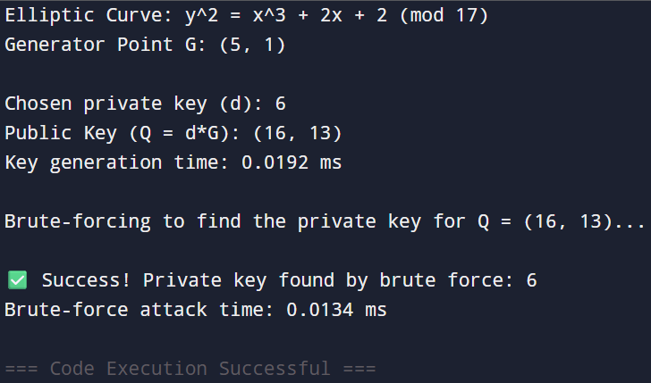

Post Lab Subjective/Objective type Questions:
- Compare RSA and ECC
Ans1) ECC provides the same security as RSA but with much smaller keys (e.g., a 256-bit ECC key is as strong as a 2048-bit RSA key). This efficiency is due to its security being based on the harder Elliptic Curve Discrete Logarithm Problem (ECDLP), unlike RSA's factoring problem. Consequently, ECC is faster and better suited for modern devices like smartphones and IoT hardware.
- List various applications of ECC.
Ans2) ECC's efficiency is critical for modern digital security. It's the standard for encrypting web traffic (HTTPS), securing private messaging apps like Signal and WhatsApp, and forms the cryptographic backbone of cryptocurrencies such as Bitcoin. It is also essential for protecting the growing network of Internet of Things (IoT) devices.
- Significance of discrete logarithm problem solution in ECDH cryptanalysis process.
Ans3) The security of the ECDH key exchange depends entirely on the difficulty of the ECDLP. In this protocol, two parties exchange public keys to establish a shared secret. An attacker who intercepts these keys can only discover the secret by deriving a private key from a public one, which is precisely the ECDLP. In short, solving the ECDLP is equivalent to breaking the ECDH key exchange.

Conclusion:
This experiment demonstrated the Elliptic Curve Discrete Logarithm Problem (ECDLP) by implementing ECC's core functions. We confirmed that generating a public key is fast, while a brute-force search is required to find the private key. The success of this attack on a small curve proves that ECC's security relies on the computational infeasibility of this search on large, real-world curves.

